Gradient Descent

Godoy I

G d

iterative optimization finding
local minimum of differentiable function

iterative technique in machine learning find best possible set of parameters / coefficients for given model data points and loss function starting from initial usually random guess

y = b + wx + eps

b bias or intercept
w weight or slope
eps noise

difference between error and loss

error difference between actual value and predicted value for single data point

loss: aggregation of errors for set of data

if use all points in training set to compute loss are performing batch gradient descend

if single point stochastic gradient descend

anything else n between 1 and N mini batch gradient descend

Git

https://git-scm.com/downloads/linux

(pytorch) wulf@gpuTwrDebS:~$ git clone https://github.com/dvgodoy/PytorchStepByStep.git

Torchviz

(pytorch) wulf@gpuTwrDebS:~$ pip install torchviz

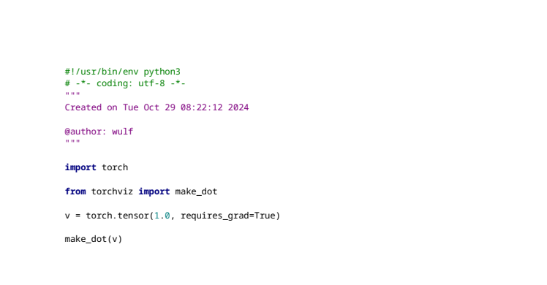

GraphViz

https://graphviz.org/download/

Tensorboard

(pytorch) wulf@gpuTwrDebS:~$ conda install -c conda-forge tensorboard

Nvidia cuDNN

https://developer.nvidia.com/cudnn-downloads?target_os=Linux&target_arch=x86_64&Distribution=Debian&target_version=12&target_type=deb_network

Pytorch Cuda

https://pytorch.org/docs/stable/notes/cuda.html

CUDA semantics
torch.cuda is used to set up and run CUDA operations. It keeps track of the currently selected GPU, and all CUDA tensors you allocate will by default be created on that device. The selected device can be changed with a torch.cuda.device context manager.

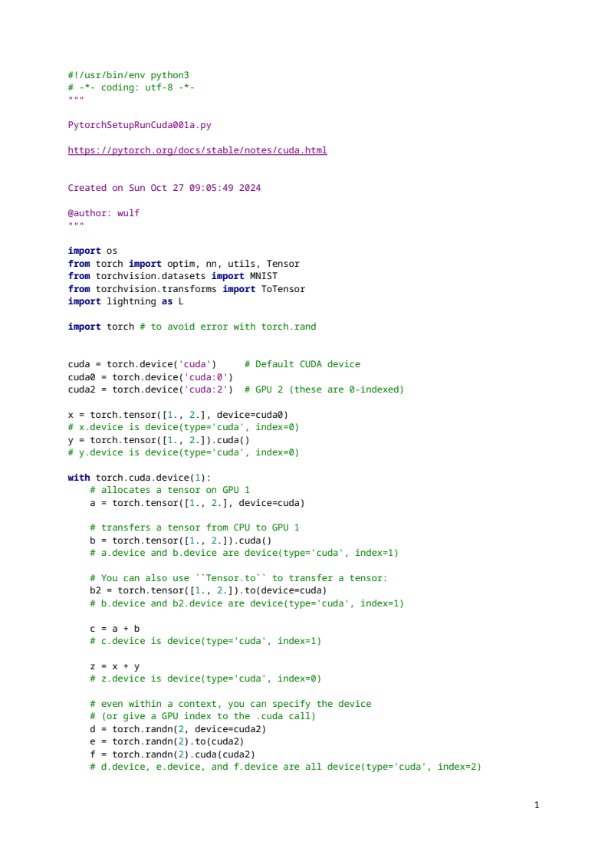
Python 3.12.7 | packaged by Anaconda, Inc. | (main, Oct 4 2024, 13:27:36) [GCC 11.2.0]
Type "copyright", "credits" or "license" for more information.

IPython 8.27.0 -- An enhanced Interactive Python.

runfile('/home/wulf/science/applied/information processing/create/code/machine learning/pytorch/untitled1.py', wdir='/home/wulf/science/applied/information processing/create/code/machine learning/pytorch')
test

runfile('/home/wulf/science/applied/information processing/create/code/machine learning/pytorch/PytorchSetupRunCuda001a.py', wdir='/home/wulf/science/applied/information processing/create/code/machine learning/pytorch')
Traceback (most recent call last):

File ~/anaconda3/envs/pytorch/lib/python3.12/site-packages/spyder_kernels/py3compat.py:356 in compat_exec
exec(code, globals, locals)

File ~/science/applied/information processing/create/code/machine learning/pytorch/PytorchSetupRunCuda001a.py:16
from torch import optim, nn, utils, Tensor

ModuleNotFoundError: No module named 'torch'

2024-10-27
Installation of Pytorch needed.

https://pytorch.org/get-started/locally/

ModuleNotFoundError: No module named 'lightning'

anaconda Pytorch env

attempt to install lightning

LibMambaUnsatisfiableError: Encountered problems while solving:
- package lightning-2.0.9.post0-py310h06a4308_0 requires python >=3.10,<3.11.0a0, but none of the providers can be installed

Anaconda new environment created python 3.10.15 pytorch_II

in terminal of environment:

conda install pytorch torchvision torchaudio pytorch-cuda=11.8 -c pytorch -c nvidia

PytorchSetupRunCuda001a1.py
ModuleNotFoundError: No module named 'lightning'

runfile('/home/wulf/science/applied/information processing/create/code/machine learning/pytorch/PytorchSetupRunCuda001a1.py', wdir='/home/wulf/science/applied/information processing/create/code/machine learning/pytorch')
Reloaded modules: torch.ops, torch.classes, _remote_module_non_scriptable
Traceback (most recent call last):

File ~/anaconda3/envs/pytorch_II/lib/python3.10/site-packages/spyder_kernels/py3compat.py:356 in compat_exec
exec(code, globals, locals)

File ~/science/applied/information processing/create/code/machine learning/pytorch/PytorchSetupRunCuda001a1.py:33
x = torch.tensor([1., 2.], device=cuda0)

File ~/anaconda3/envs/pytorch_II/lib/python3.10/site-packages/torch/cuda/__init__.py:319 in _lazy_init
torch._C._cuda_init()

RuntimeError: Found no NVIDIA driver on your system. Please check that you have an NVIDIA GPU and installed a driver from http://www.nvidia.com/Download/index.aspx

https://developer.nvidia.com/cuda-downloads

install the open kernel module flavor: sudo apt-get install -y nvidia-open

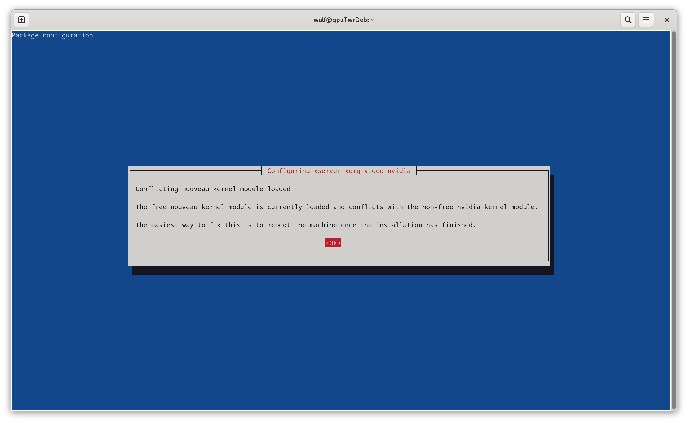

…
update-initramfs: Generating /boot/initrd.img-6.1.0-26-amd64
(base) wulf@gpuTwrDeb:~$

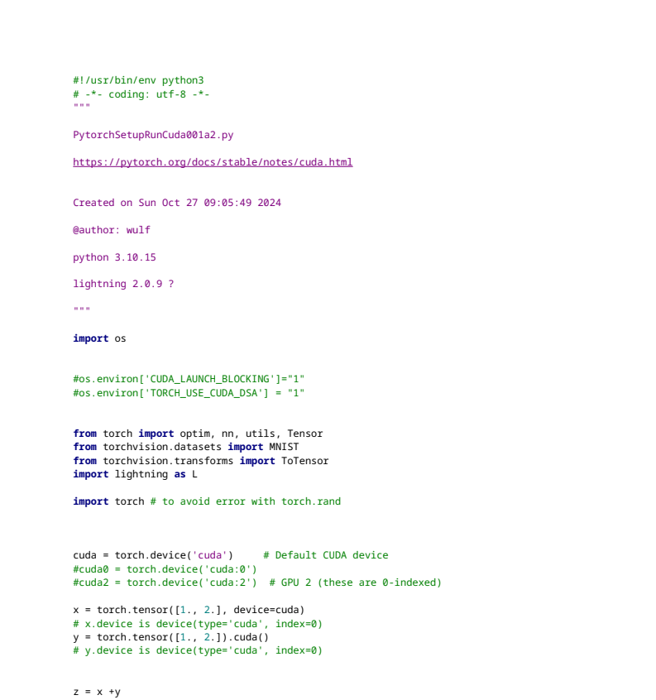
runs

-------------------------------------------
PytorchSetupRunCuda001a1.py

RuntimeError: CUDA error: invalid device ordinal
CUDA kernel errors might be asynchronously reported at some other API call, so the stacktrace below might be incorrect.
For debugging consider passing CUDA_LAUNCH_BLOCKING=1
Compile with `TORCH_USE_CUDA_DSA` to enable device-side assertions.

torch.cuda.get_device_name(0)
Out[3]: 'NVIDIA GeForce RTX 2070'

----------------------------------------------------------------------------

NOTE: Latest PyTorch requires Python 3.9 or later.
PyTorch Build
Your OS
Package
Language
Compute Platform
Run this Command:
Stable (2.5.0)
Preview (Nightly)
Linux
Mac
Windows
Conda
Pip
LibTorch
Source
Python
C++ / Java
CUDA 11.8
CUDA 12.1
CUDA 12.4
ROCm 6.2
CPU
conda install pytorch torchvision torchaudio pytorch-cuda=11.8 -c pytorch -c nvidia
conda install pytorch torchvision torchaudio pytorch-cuda=11.8 -c pytorch -c nvidia

ROCM

apparently installed gpu not supported by ROCM

check gpu

VGA compatible controller: NVIDIA Corporation TU106 [GeForce RTX 2070 Rev. A] (rev a1) (prog-if 00 [VGA controller])
Subsystem: Gigabyte Technology Co., Ltd TU106 [GeForce RTX 2070 Rev. A]

https://rocm.docs.amd.com/projects/install-on-linux/en/latest/install/prerequisites.html

Supported GPUs
The following table shows the supported AMD Instinct™ accelerators, and Radeon™ PRO and Radeon GPUs. If a GPU is not listed on this table, it’s not officially supported by AMD.
Accelerators and GPUs listed in the following table support compute workloads (no display information or graphics). If you’re using ROCm with AMD Radeon or Radeon Pro GPUs for graphics workloads, see the Use ROCm on Radeon GPU documentation to verify compatibility and system requirements.
GPU | Architecture | LLVM target | Support
AMD Radeon RX 7900 XTX | RDNA3 | gfx1100 | ✅
AMD Radeon RX 7900 XT | RDNA3 | gfx1100 | ✅
AMD Radeon RX 7900 GRE | RDNA3 | gfx1100 | ✅
AMD Radeon VII | GCN5.1 | gfx906 | ⚠️

Have

https://rocm.docs.amd.com/projects/install-on-linux/en/latest/install/prerequisites.html

(base) wulf@gpuTwrDeb:~$ uname -srmv
Linux 6.1.0-26-amd64 #1 SMP PREEMPT_DYNAMIC Debian 6.1.112-1 (2024-09-30) x86_64

https://packages.debian.org/bookworm/libpython3-dev

root@gpuTwrDeb:~# amdgpu-install -y –usecase=graphics,rocm

INFO: i386 architecture has not been enabled with dpkg.
Installation of 32-bit run time has been excluded.

Hit:1 http://deb.debian.org/debian bookworm InRelease
Hit:2 http://security.debian.org/debian-security bookworm-security InRelease
Get:3 http://deb.debian.org/debian bookworm-updates InRelease [55.4 kB]
Hit:4 https://repo.radeon.com/amdgpu/6.2.3/ubuntu jammy InRelease
Hit:5 https://developer.download.nvidia.com/compute/cuda/repos/debian12/x86_64 InRelease
Hit:6 https://repo.radeon.com/rocm/apt/6.2.3 jammy InRelease
Fetched 55.4 kB in 1s (51.6 kB/s)
Reading package lists... Done
Reading package lists... Done
Building dependency tree... Done
Reading state information... Done

Some packages could not be installed. This may mean that you have
requested an impossible situation or if you are using the unstable
distribution that some required packages have not yet been created
or been moved out of Incoming.

The following information may help to resolve the situation:

The following packages have unmet dependencies:
rocm-gdb : Depends: libpython3.10 (>= 3.10.0) but it is not installable
E: Unable to correct problems, you have held broken packages.
root@gpuTwrDeb:~#

root@gpuTwrDeb:~# apt list --upgradable -a
Listing... Done

error:
rocm-gdb : Depends: libpython3.10 (>= 3.10.0) but it is not installable

check the kernel version of your Linux system

(pytorch) wulf@gpuTwrDeb:~$ uname -srmv
Linux 6.1.0-26-amd64 #1 SMP PREEMPT_DYNAMIC Debian 6.1.112-1 (2024-09-30) x86_64

(pytorch) wulf@gpuTwrDeb:~$ uname -m && cat /etc/*release
x86_64
PRETTY_NAME="Debian GNU/Linux 12 (bookworm)"
NAME="Debian GNU/Linux"
VERSION_ID="12"
VERSION="12 (bookworm)"
VERSION_CODENAME=bookworm
ID=debian
HOME_URL="https://www.debian.org/"
SUPPORT_URL="https://www.debian.org/support"
BUG_REPORT_URL="https://bugs.debian.org/"

runfile('/home/wulf/science/applied/information processing/create/code/machine learning/pytorch/PytorchDemo002b.py', wdir='/home/wulf/science/applied/information processing/create/code/machine learning/pytorch')
File <unknown>:97
tensorboard --logdir .
^
SyntaxError: invalid syntax

